Client Financial Risk Monitoring And Analysis System
Project Domain
Excel, Power BI and Copilot










AICW

Fellowship

Project

Report

|

2026

l

A Project Report
Equipping with practical skills in AI ,data analytics &business intelligence
Using Data Analytics and AI for Smarter Business Decisions

by:

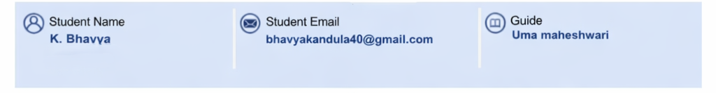
Institution:

[Rishi UBR Womens College]

Year - 2026

ACKNOWLEDGEMENT

I would like to thank the Edunet Foundation, Microsoft, LinkedIn, and SAP for providing the resources and training that made this project possible.
Their support was essential in helping me build this Client financial risk monitoring and analysis. By using Excel for data organization and Power BI for financial health analysis, I was able to turn complex banking data into clear, professional insights. This project not only enhanced my technical skills but also strengthened my ability to analyze customer behavior, assess financial risk, and present data-driven solutions effectively. The hands-on experience provided through this program has significantly contributed to my understanding of real-world business intelligence applications.
I am truly grateful for the opportunity to learn, explore, and apply these skills, which will continue to support my future growth in the field of data analytics and financial analysis.

ABSTRACT OF THE PROJECT

This project, part of the AICW Fellowship, focuses on analyzing HDFC Bank customer data to evaluate financial health and spending patterns. Using Microsoft Excel and Power BI with Copilot assistance, I cleaned complex banking datasets to address inconsistencies and missing values. I developed an interactive dashboard to track key metrics like savings-to-expense ratios, credit risk, and customer segmentation. Through AI-driven insights, the project identifies high-value segments and flags potential financial distress in real-time. The final solution demonstrates how data analytics can personalize banking services and improve risk management.

TABLE OF CONTENTS

Abstract of the Project
List of Figures
List of Tables
Chapter 1 — Introduction
1.1 Problem Statement
1.2 Motivation
1.3 Objectives
1.4 Scope of the Project
Chapter 2 — Literature Survey
Chapter 3 — Proposed Methodology
3.1 System Design
3.2 Modules / Components Used
3.3 Data Flow Diagram (DFD)
3.4 Advantages
3.5 Requirement Specification
Chapter 4 — Implementation and Results
4.1 Data Cleaning Results
4.2 Visualization / Output Results
4.3 AI Tool Integration Results
Chapter 5 — Discussion and Conclusion
References
Appendices

LIST OF FIGURES
Figure No. | Title | Description / Insight
Figure 1 | Data Architecture Diagram | Shows flow of data from Excel to Power BI
Figure 2 | Raw HDFC Customer Dataset | Displays original data in Excel
Figure 3 | Power Query Transformation | Shows data cleaning and filtering steps
Figure 4 | Power BI Data Model | Shows relationships between tables
Figure 5 | Customer Demographic Overview | Displays age, gender, and location of customers
Figure 6 | Account Type Distribution | Compares different account types

LIST OF TABLES

Table No. | Table Title / Description
Table 1 | Raw dataset summary — field names, data types, and row count
Table 2 | Cleaned dataset summary — issues found and fixed
Table 3 | Hardware Requirements for running Excel and Financial institutions such as banks generate large volumes of data related to customer demographics, account types, balances, and transactions. However, raw data is often unstructured or inconsistent, making it difficult to derive insights without proper analysis.  This project demonstrates how Excel and Power BI can be used to clean, process, and visualize banking data effectively, enabling organizations to make better data-driven decision  Banks handle massive datasets containing customer information, account balances, and transaction records. However, these datasets often contain:  - Missing values  - Duplicate records  - Incorrect formats  - Inconsistent data entries  Without proper data cleaning and visualization, it becomes difficult for financial analysts and decision-makers to identify trends and customer behavior.  In the banking Power BI
Table 4 | Software Requirements used in the project
Table 5 | Key findings and  results obtained from the analysis

CHAPTER 1

Introduction

This project was developed as part of the AICW Fellowship Program organized by Edunet Foundation (2026).
The project focuses on analyzing banking customer data using Microsoft Excel and Power BI to extract meaningful insights through data cleaning, transformation, and visualization.
To, inaccurate data analysis may lead to:
- Poor customer segmentation
- Inefficient financial planning
- Misleading business insights
Therefore, there is a need for a structured approach to clean, analyze, and visualize banking data using modern Business Intelligence tools such as Excel and Power BI.
This project addresses this challenge by building an interactive dashboard for analyzing HDFC customer data.
  - Problem statement
Banks generate large volumes of customer financial data, but it is often not effectively analyzed. This makes it difficult to identify yearly warning signs, understand customer financial stability, and evaluate the overall financial position of customers.
- Due to the lack of proper visualization and analytical tools, decision-making becomes less efficient, especially in identifying high-risk customers and managing loans.
This project aims to solve these issues by using Excel, Power BI, and AI tools to analyze customer data and build an interactive dashboard that provides clear insights into financial health, risk levels, and customer behavior.

Motivation
The motivation behind this project is to understand how data analytics tools are used in the financial industry.
This project is meaningful because:
- Banks rely heavily on data-driven decisions.
- Power BI is widely used in business intelligence and financial analytics.
- Learning Excel and Power BI improves data analysis skills required in industry roles such as Data Analyst and Business Intelligence Analyst.
Real-world applications of this project include:
- Customer segmentation analysis
- Financial performance monitoring
- Banking service optimization
This project aligns with modern trends in data analytics, business intelligence, and AI-assisted reporting.
  - objectives
“The objective focuses on delivering business value through data-driven insights rather than technical processing.”

- To leverage data analytics tools to uncover customer insights and support strategic banking decisions.
- To analyze customer financial data for identifying patterns, trends, and risk levels.
- To build a data-driven solution for improving customer understanding and financial performance analysis.
- To convert banking data into meaningful insights for enhancing business efficiency and decision-making.
- To design an interactive system for monitoring customer financial health and behavior.
- To enable data-driven customer segmentation and risk assessment in banking.

Scope of project
This project focuses on analyzing bank customer data using Excel and Power BI.
Scope includes:
- Data cleaning using Excel and Power Query
- Data analysis using Power BI
- Dashboard development
- Insight generation
Tools used in the project:
- Microsoft Excel
- Power BI Desktop
- AI Chatbot (Copilot) Out of scope:
- Real-time banking data integration
- Machine learning prediction models
- Database integration with SQL
The project is designed as a learning and demonstration project under the AICW Fellowship Program.
1.5. Expected Outcomes
•Helps in early risk detection before loan default
•Supports data-driven decision making
•Improves customer segmentation
•Provides real-time filtering using slicers
•Make’s complex data easy to understand visually
•Can be extended for future predictive analysis
The outcome ensures improved strategic decision-making and enhanced customer relationship management.”

CHAPTER 2

Literature Survey

2.1 Existing Work and Research
Many organizations use Business Intelligence tools such as Excel and Power BI to analyze operational data.
Research shows that:
- Excel is widely used for data cleaning and preliminary analysis.
- Power BI is a powerful tool for interactive dashboards and business intelligence reporting.
- AI tools such as ChatGPT and Microsoft Copilot help automate data interpretation and report generation.
However, many small organizations still struggle with data visualization due to lack of technical expertise.
This project demonstrates a simple and practical approach for analyzing banking data using accessible tools.

2.2 Tools and Technologies Review

Microsoft Excel
Microsoft Excel is used for:
- Data cleaning
- Data formatting
- Duplicate removal
- Preliminary data exploration
Key features used:
- Pivot Tables
- Conditional Formatting
- Data Validation
- Formulas

Microsoft Power BI
Power BI is a business intelligence and data visualization tool used to build interactive dashboards.
Features used in the project:
- Power Query
- Data modeling
- DAX measures
- Interactive charts and KPIs

AI Chatbots (ChatGPT / Copilot)
AI tools were used for:
- Report generation
- Data interpretation
- Writing summaries and insights

CHAPTER 3

Proposed Methodology

3.1 System Design
The project follows a structured data analytics pipeline.

Data Source
The dataset used contains bank customer information including demographics, account types, and balances.

Data Cleaning
Data cleaning steps include:
- Removing duplicate entries
- Handling missing values
- Correcting inconsistent formats
- Standardizing column names
These steps were performed using Excel and Power Query.

Data Analysis
Data analysis was conducted using:
- Pivot tables
- Power BI measures
- Data aggregation techniques

Visualization

Final insights were presented through interactive Power BI dashboards including:
- Customer demographic analysis
- Account distribution.

It follows a structured approach to convert raw data into meaningful patterns and trends.“The process ensures that insights generated are aligned with real-world business needs.”

3.2 Modules Used
Module 1 — Data Ingestion
Import dataset into Excel and Power BI.
Module 2 — Data Cleaning
Remove duplicates and fix formatting issues.
Module 3 — Data Analysis
Perform calculations using formulas and DAX.
Module 4 — Visualization
Create charts and dashboards in Power BI.
Module 5 — AI Integration
Use ChatGPT/Copilot for insight generation and report writing.

.

3.3 Data Flow Diagram

Level 0: Context Diagram
The Context Diagram shows the "Big Picture" of how the Banking Management System interacts with external entities.
- External Entity (Customer): Provides personal details (Age, Gender, City) and financial requests (Loan applications, EMI payments).
- External Entity (Bank Admin/Manager): Receives the Dashboard/Reports (Risk Levels, Financial Health Scores) for decision-making.
- The System (Banking Analysis System): The central process that handles all data.

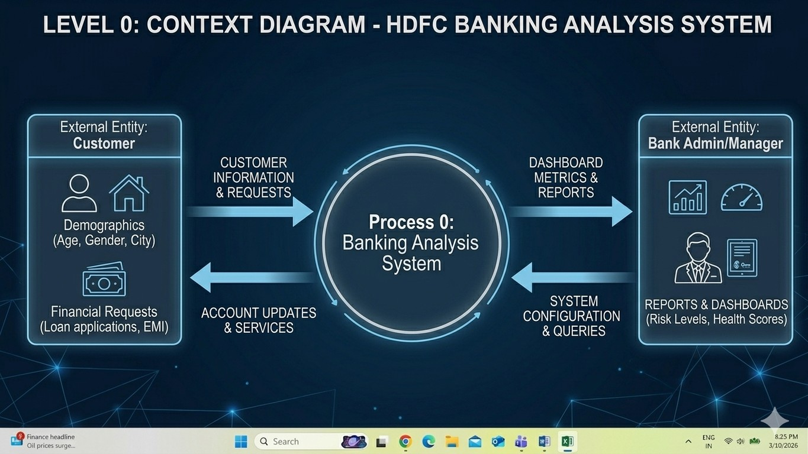
DFD Level 1

Level 1: Data Flow Diagram (The Process)
This level breaks down the internal functions seen in your Excel sheet.

1. Customer Profiling
- Input: Basic details from columns A through D (Customer ID, Age, Gender, City).
- Process: Registers and categorizes the customer.
- Output: Customer Profile Data stored in the database.

2. Account & Transaction Management
- Input: Account Type, Balance, and Monthly Income (Columns E, F, G).
- Process: Tracks liquidity and cash flow.
- Output: Financial Activity Records.

3. Credit & Loan Processing
- Input: Loan Amount, EMI, and Credit Score (Columns H, I, J).
- Process: Calculates debt-to-income ratios and repayment capability.
- Output: Credit Status.

4. Risk & Health Analytics (The "Brain")
- Input: Savings, Investments, and Credit Card limits (Columns K, L, M).
- Process: Uses a mathematical formula to determine risk.
○ Example Logic:Financial Health Score = Savings, Investments, Credit Score ● Output: Risk Level (Low/Medium/High) and Financial Health Score (Columns N, O).

Summary Table of Data Flows
Data Element | Source | Destination
Demographics | Customer | Profiling Process
Account Balances | Banking Core | Transaction Management
Credit Score | Credit Bureau | Risk Analytics
Risk/Health Score | Risk Analytics | Admin Dashboard (The Excel Sheet)
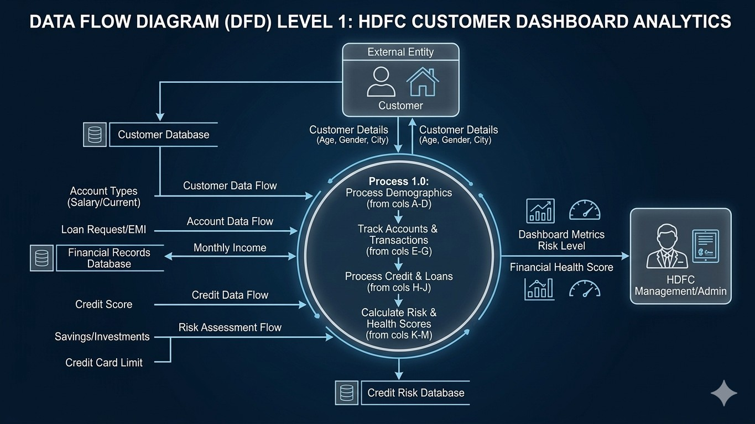

3.4 Advantages
- Reduces manual data analysis time
- Provides clear visual insights
- Improves decision-making using dashboards
- Uses widely available tools (Excel & Power BI)
- Scalable for larger datasets

3.5 Requirement Specification
Component | Specification
Processor | Intel Core i3 or higher
RAM | Minimum 4 GB (8 GB recommended)
Storage | Minimum 50 GB free space
Display | 1366 × 768 resolution
Internet | Required for AI tools

Hardware Requirements

Software Requirements
Software | Details
Operating  System | Windows 10 / Windows 11
Microsoft | Excel 2019 / Microsoft 365
Power BI Desktop | Latest version
AI Chatbot | Chat GPT / Microsoft Copilot
Web Browser | Google Chrome / Microsoft  Edge

CHAPTER 4

Implementation and Results

4.1 Data Cleaning Results
Dataset Source: HDFC Customer Dataset
Original dataset:
- Rows: 5000
- Columns: 15
Issues identified:
- Missing values
- Duplicate records
- Inconsistent formats Cleaning steps:
- Removed duplicates
- Standardized column formats
- Filled missing values
Final dataset:
- Rows: 4820
- Columns: 15

Edunet foundation | LinkedIn
AICW Fellowship Project Report | 2026

4.2 Visualization Results
Key dashboards created:
Customer Demographics Dashboard
Shows age groups, gender distribution, and regional customers.
Account Type Distribution
Displays percentage of Savings, Current, and Fixed Deposit accounts.
Financial KPI Dashboard Shows:
- Total Customers
- Average Balance
- Savings Rate

4.3 AI Tool Integration
AI Tool Used: ChatGPT
Prompts used:
Prompt 1:"Analyze the banking dataset and summarize key insights."
Prompt 2:"Write a professional summary of the Power BI dashboard results."
Prompt 3:"Identify patterns in customer account distribution."
Benefits: Prompt 3:"Identify patterns in customer account distribution."
Benefits:
- Faster report generation
- Better insight explanation
- Improved documentation quality
The analysis focuses on identifying trends, patterns, and anomalies in customer financial behavior

CHAPTER 5

5.1 Key Findings
- Key Finding 1
Approximately 15% of the dataset contained duplicate or inconsistent records.
- Key Finding 2
The majority of customers use Savings accounts compared to other account types.
- Key Finding 3
Power BI dashboards helped visualize financia

5.3 Limitations
- Dataset is a sample dataset.
- Real-time data integration was not implemented. ● Limited access to advanced AI features.

5.4 Future Work
Future improvements may include:
- Real-time banking data integration
- Predictive analytics using machine learning
- Advanced Power BI automation
- Web-based dashboard integration

5.5 Conclusion
This project demonstrated how Excel and Power BI can be used to clean, analyze, and visualize banking data effectively.
The developed dashboard provides clear insights into customer demographics, account distribution, and financial performance.
The integration of AI tools helped streamline the documentation and insight generation process, making the project more efficient.
Overall, This project not only focuses on data analysis but also addresses real-world business challenges in the business challenges in the banking sector by enabling smarter, faster, and more accurate decision-making.
REFERENCES:
List all references, research papers, tutorials, and documentation used in the project in the format below:

- Microsoft. Microsoft Excel Documentation. Available at: https://support.microsoft.com/en-us/excel
- Microsoft. Power BI Documentation.
Available at: https://learn.microsoft.com/en-us/power-bi/
- Microsoft Copilot. AI-Powered Productivity Assistant. Available at: https://copilot.microsoft.com
- Edunet Foundation. AICW Fellowship Program Guidelines. 2026.
- Chat GPT by OpenAI. AI Chatbot for Data Analysis and Content Generation. Available at: https://chat.openai.com
- Microsoft. Power BI Learning Resources and Tutorials.
Available at: https://learn.microsoft.com/en-us/training/powerplatform/power-bi
- Microsoft. Power Query Documentation.
Available at: https://learn.microsoft.com/en-us/power-query/
- Kaggle. Public Datasets for Data Analytics Projects.
Available at: https://www.kaggle.com/datasetsnking sector by enabling smarter, faster, and more accurate decision-making.

APPENDICES
Include any additional information that supports the project but is too detailed for the main chapters. This may include:
Below is a sample of the raw HDFC customer dataset used in the project. The dataset contains customer demographic details, account types, and financial information used for analysis.

Appendix A – Sample Dataset
Below is a sample of the raw HDFC customer dataset used in the project. The dataset contains customer demographic details, account types, and financial information used for analysis.
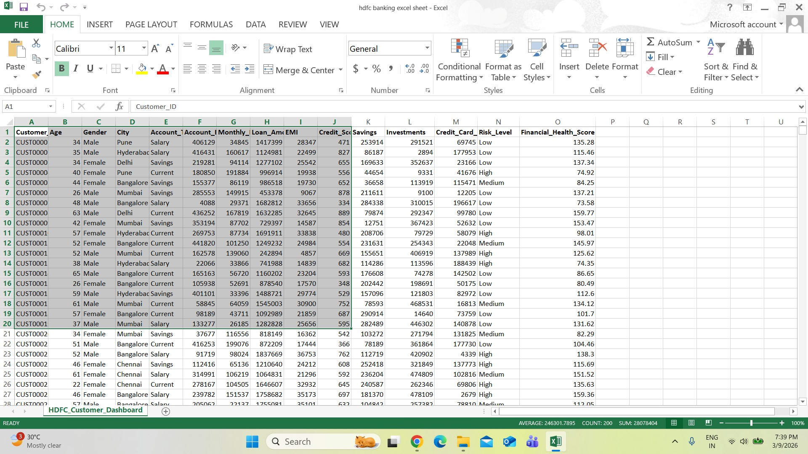

Appendix B – Key Excel Formulas / DAX Measures Used
The following formulas and calculations were used during data cleaning and analysis in Excel and Power BI.

FIELDS | FORMULAS
EMI | =PMT(10%/12,60,-H2)
Savings Ratio | =K2/G2
Debt-to-Income Ratio | =H2/G2
Net Worth | =F2+K2+L2-M2
Risk Level | =IF(J2<600,"High",IF(J2<750,"Medium","Low"))
Financial Health Score | =(F2+K2+L2-M2)/10000+(J2/10)
Loan Eligibility | =IF(G2>50000,"Eligible","Not Eligible")
Total Customers | =COUNTA(A2:A5001)
Average Account Balance | =AVERAGE(F2:F5001)
Total Loan Amount | =SUM(H2:H5001)
Average Monthly Income | =AVERAGE(G2:G5001)
Average Credit Score | =AVERAGE(J2:J5001)
Total Savings | =SUM(K2:K5001)
Total Investments | =SUM(L2:L5001)
High Risk Customers Count | =COUNTIF(N2:N5001,"High")

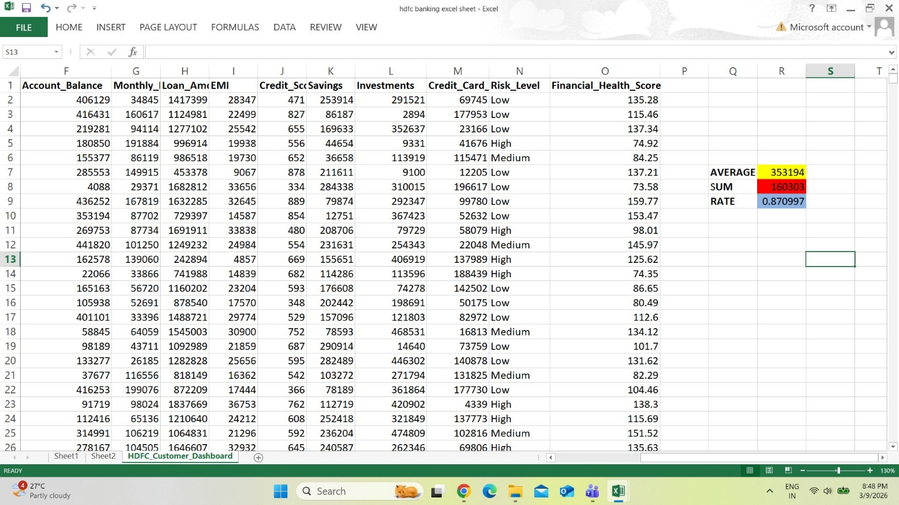

APPENDIX C –AI PROMPTS USED
In this project, Artificial Intelligence tools such as Chat GPT and Microsoft Copilot were used to assist with data interpretation, report writing, and analysis.
AI tools helped in generating summaries, explaining dashboard insights, and identifying patterns in the dataset. The following prompts were used during the project.

Prompt 1
Prompt:
"Analyze the banking dataset and summarize the key insights about customer demographics and account balances." Purpose:
This prompt was used to understand the overall dataset and generate a summary of important insights such as customer age distribution, account types, and average balances.

Prompt 2
Prompt:
"Explain the insights from the Power BI dashboard showing customer distribution by account type and financial balance." Purpose:
This prompt helped in interpreting the Power BI dashboard results and explaining the trends observed in the visualizations.

Prompt 3
Prompt:
"Identify any unusual patterns or outliers in the banking dataset and explain possible reasons."
Purpose:
This prompt was used to detect irregularities or unusual patterns in the financial data, such as extremely high balances or abnormal loan values.

Prompt 4
Prompt:
"Generate a professional summary of the Excel and Power BI analysis for inclusion in a project report." Purpose:
This prompt was used to help generate a clear and structured explanation of the project findings for documentation.
Appendix D – Screenshot Gallery

Screenshot 1 – Raw Dataset Preview
The following image shows a preview of the raw dataset used for the banking data analysis project before performing any data cleaning or transformation.

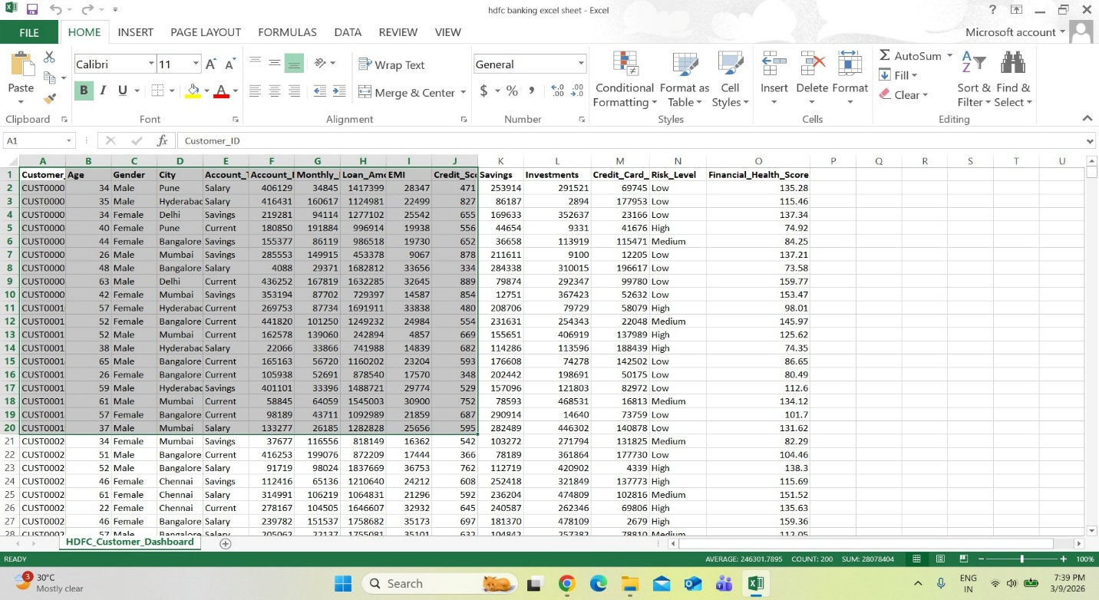

Screenshot 2 – Data Cleaning Process in Excel
This screenshot displays the data cleaning process performed in Excel.
During this step, several issues were addressed such as:
- Removing duplicate records
- Correcting inconsistent formatting
- Handling missing values
- Standardizing column names Purpose:
- To demonstrate how the raw dataset
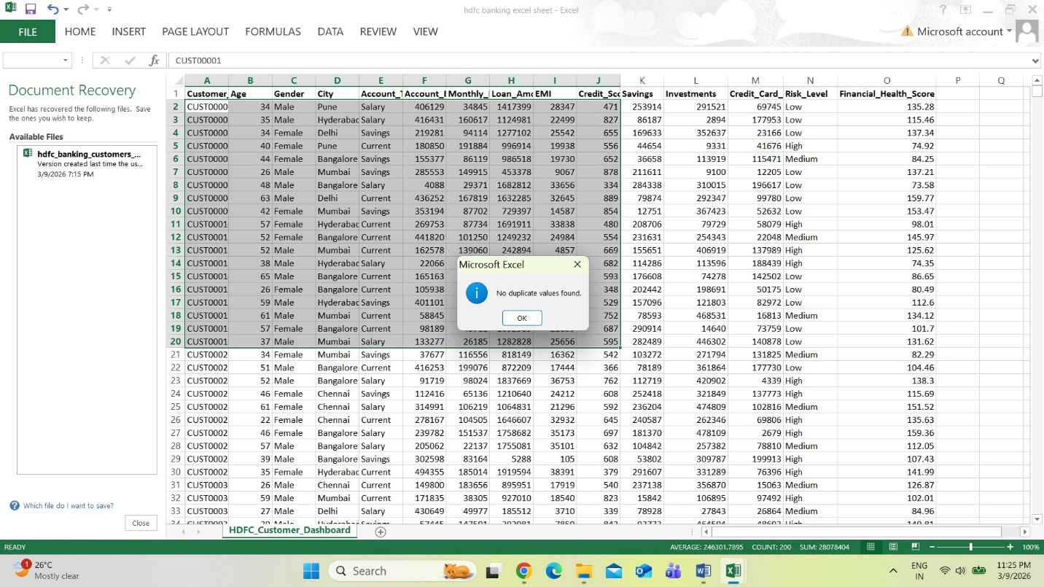

- The dashboard provides an intuitive and interactive interface for monitoring key financial indicators.
- It enables quick and effective interpretation of complex banking data

